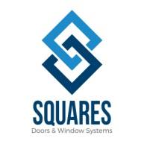 upvc doors and windows manufacturers ……………
Squares are the top upvc windows and doors manufacturers in Hyderabad, is your one-stop-shop upvc doors and windows suppliers of top brand quality upvc windows and doors. We offer fabricators, real estate contractors and installers—from professional individuals to big companies—the very best uPVC products.
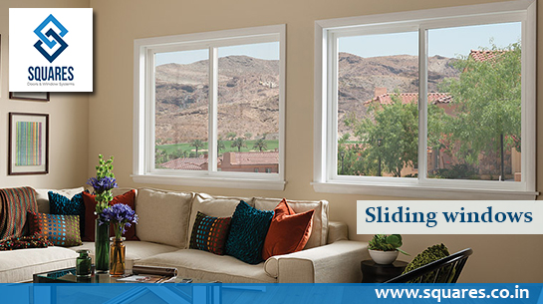
All our valued customers and distributors have access to our comprehensive catalogue of all our inventory, as well as other added complimentary services such as free quotations on products, bulk discounts, and delivery service. Our best sellers in our product line are the innovative and trendy uPVC sliding windows and uPVC sliding doors in various styles to choose from. We also have a wide range of uPVC profiles and accessories. Machines are also available. No matter what the materials or measurements our customers require, we have a huge range of stock and ready to be delivered. To top it all, our uPVC products are very affordable and competitive in price. We are the perfect solution to all your uPVC product needs and requirements and we provide quick and efficient service. Squares are the most reliable upvc doors and windows manufacturers. We design windows which are customized as per the needs of the customers. uPVC is perfectly suited for Indian climatic conditions and we adhere to very high quality standards.
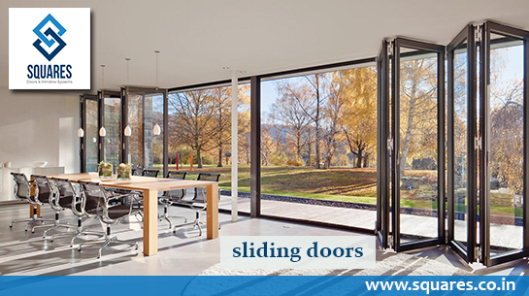
They come in a lot of varieties. We are upvc sliding doors manufacturers and UPVC sliding door suppliers. They slide horizontally to their left and right on two tracks and panels. We stand as the best upvc sliding door dealers. Also a upvc casement windows manufacturer. Casement windows are also offered which are side hung windows and open inside or outside. Tilt and turn windows are also available.Squares are renowned upvc windows manufacturers and upvc windows suppliers. These windows protect your living space from dust, rain and noise pollution. These windows are very durable and sturdy. They can last for years and are a value for money. They provide energy efficiency and comfortable living conditions. Our UPVC windows are of international quality and are suited for variety of ambience. These windows are fire resistant and strong. They are reasonable priced and low maintenance. Repainting is not required as these windows are stain proof. They can just be wiped clean and they begin to look like new.
Our products are very durable and heat insulated. These products are environment friendly and meet all the norms. They are energy saving and keep a room cool and pleasant. They do not allow fire to spread. Our company employs an experienced and helpful customer service team on hand to answer your inquiries and other sales concerns. Contact us at Squares uPVC today for a fruitful partnership because we are upvc doors manufacturers and upvc doors suppliers.
To Get More Details Visit us @ http://squares.co.in/ or Contact us @ 9949236666

